Sensing Temperature using RTD

The project expect to produce a data adquisition system for temperature and visualize it using NODERED o Thingsboad.

# System Description

Temperatureis the mostessentialfactorthatneedscontinuousmeasurementand monitoring in many process.

Design Specifications

gasrfga

|  |  |
| --- | --- |
| PARAMETERS | SPECIFICATIONS AND FEATURE |
| Temperature Sensing Range | -30ºC to 100ºC |
| Measurement Accuracy | < ± 0.1º |
| ADC resolution and type | 24-bit,ΔΣ ADC with differential inputs |
| ADC interface for digital data | SPI |
| RTD Sensor type | 2-, 3-, and 4-wire input |
| Number of RTD inputs | 4 |
| Current sources and excitation current range | Dual matched current source 0.1 mA |
| Resistance measurement method | Ratiometric |
| DC input voltage | 3.3 V |
| AC power supply | 3.3 V |
| Indication | LED for the RTD in use. |
| Interface connectors | 4-pin screw-type terminal block for each RTD  40-pin Socket Connector with long tails  4mm Brass Socket PSU |

# Block Diagram

The ADS1248 integrates all necessary features (such as dual-matched programmable current sources, buffered reference inputs, PGA, and so forth) to ease the implementation of ratiometric 2-, 3-, and 4-wire RTD measurements.

The general diagram of the system to measure 4 RTDs:

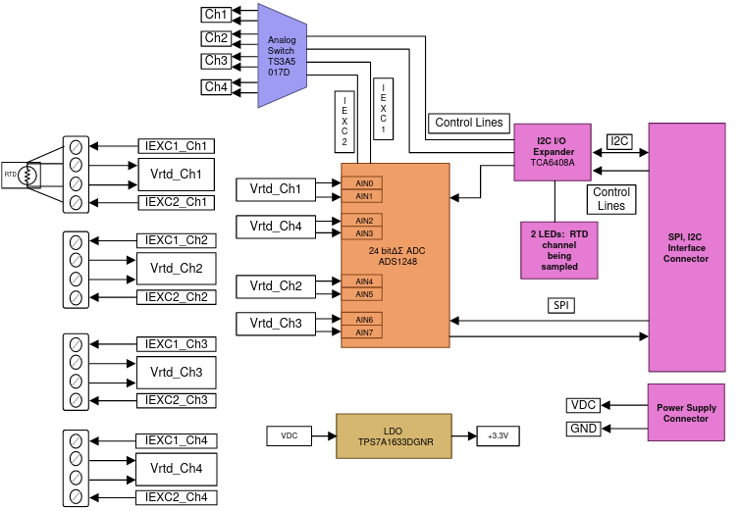

## ADC

The design allows to measures of 4 RTDs with an ADS1248. The ADS1248 is a highly-integrated, precision, 24-bit ADC. The ADS1248 features an on board, low-noise, programmable gain amplifier(PGA), a precision ΔΣ ADC with a single-cycle settling digital filter, and an internal oscillator. ADS1248 also provides a built-in, very low-drift voltage reference with a 10-Ma output capacity, and two matched programmable current digital-to-analog converters(DACs). The ADS1248 provides a complete front-end solution for temperature sensor applications including thermal couples, thermistors, and RTDs.

ADS1248 has the following features:

* Four differential inputs.
* Matched current source for RTD excitation
* PGA with gain up to 128
* Internal reference with provision to configure for external reference.
* SPI for configuration and ADC sample reading.
* Chip Select and START to control sampling.

## Dual 4:1 Analog Switch

This design uses dual-matched current source. This current is switched between four RTDs. TS3A5017D is used to switch excitation current between RTDs. The TS3A5017is a dual single-pole quadruple-throw (4:1) analog switch that operates from 2.3 to 3.6 V and can handle analog signals

## Power Supply

The design runs on +3.3V supply. The supply should be stable. The RPI3, which acts as mezzanine board should prove the +3.3V.

## LED Indicators

Four LEDS are provided to indicate the RTD input channel being scanned.

## Interfaces

The acquisition system is connected in a sandwich with a RPI3 board which will control the behaviour.

# Circuit Design

The 4 RTD inputs are connected to four differential inputs of the ADS1248. The differential inputs are guided to the low noise PGA with a multiplexer.

The PGA provides selectable gain of 1 to 128.

The ∆∑ modulator and adjustable digital filter support up to 2kSPS.

Internal reference and external reference might be selected. The external reference voltage is the differential voltage between REFP and REFN: VREF = VREFP - VREFN.

INCLUIR UN DIAGRAMA CON EL ADC y sus INTERCONEXIONES

## 3-wire RTD calculation

The most common case is

### RREF and PGA gain

The resistance of the PT1000 (NB-PTCO-151) changes from:

|  |  |  |  |  |
| --- | --- | --- | --- | --- |
| -30 ºC | 0 ºC | 30 ºC | 80 ºC | 100 ºC |
| 882.20 Ohm | 1000.00 Ohm | 1116.70 Ohm | 1248.00 Ohm | 1385.10 Ohm |

The IDAC current must be 1mA or less to minimize self-heating. The IDAC current chose is I1 = 500µa.

Then the maximum and minimum input voltage to the PGA are (assuming RLEAD = 0Ω):

1382.10 -1000 = 382.10 Ohm => VINMAX= 382.10 Ohm * 0.500mA = 191.05 mV

1000 – 882.20 = 117.8 Ohm => VINMAX= 117.8 Ohm * 0.500mA = 58.9 mV

The external reference resistor RREF should be a precision low-drift reference resistor. It serves two purposes:

* It decides the external reference voltage for ADC
* It also determines the input common mode voltage of the PGA.

Set the common mode voltage around mid-supply (AVDD– AVSS)/ 2 = (3 V – 0 V) / 2 = 1.65V. Therefore, the reference voltage chosen

VREF=2 V, VREF=1.5, VREF=2.2V

which also depends on easily available resistance value and excitation current.

VREF = (IDAC1 + IDAC2) * RREF

Because IDAC1 = IDAC2 = 0.500mA => VREF = 2* IDAC1 * RREF

RREF = VREF/(2*IDAC1) = 2V (2* 0.500mA) = 2KOhm

RREF = VREF/(2*IDAC1) = 1.5V (2* 0.500mA) = 1.5KOhm

RREF = VREF/(2*IDAC1) = 2.2V (2* 0.500mA) = 2.2KOhm

GAINPGA= VREF/ VINMAX= 2V/191.05 mv = 10.46 => The nearest G=8

GAINPGA= VREF/ VINMAX= 1.5V/191.05 mv = 7.85 => The nearest G=8 !!! Max temp 90º!

GAINPGA= VREF/ VINMAX= 2.2V/191.05 mv = 11.51 => The nearest G=8

### Common-Mode voltage compliance check

he signalof an RTDis of a pseudo-differentialnature,wherethe negativeinputmustbe biasedat avoltageotherthan0 V and the positiveinputcan thenswingup to 97.04mV abovethe negativeinput.The allowedcommon-modeinputvoltagerangeis as highlightedin Figure10 (takenfromthe ADS1248datasheet

AVSS+0.1 + (VIN*Gain) /2 ≤ VCMI ≤ AVDD-0.1 - (VIN*Gain) /2

AVSS = 0; VIN = 58.9 Mv; Gain = 8; AVDD = 3.3 V; IDAC=0.500mA

VCMI_MIN= AVSS+0.1V+VIN GAIN/2 = 0V + 0.1V + (58.9mV *8)/2 = 100mV + 235.6mV = 335.6 mV

VCMI_MAX= AVDD- 0.1 - (VIN*Gain)/2 = 3.3V – 0.1V – (191.05mV*8)/2 = 3.3V - 100mV - 764.2mV = 3.3V -864.2 mV = 2.4358 V

RRTD =1385.10 Ohm

VCMI_MIN_GAIN= (IDAC*RLEAD)+ IDAC*RRTD/2+2*IDAC*(RLEAD+RREF)= 0.500mA*1385.10/2 + 2* 0.500mA*2K=0.346+2= 2.346V

VCMI_MIN_GAIN= (IDAC*RLEAD)+ IDAC*RRTD/2+2*IDAC*(RLEAD+RREF)= 0.500mA*1385.10/2 + 2* 0.500mA*1.5K=0.346+1.5= 1.846V

VCMI_MIN_GAIN= (IDAC*RLEAD)+ IDAC*RRTD/2+2*IDAC*(RLEAD+RREF)= 0.500mA*1385.10/2 + 2* 0.500mA*1.5K=0.346+2.2= 2.546V

RRTD =882.20 Ohm

VCMI_MAX_GAIN= (IDAC*RLEAD)+ IDAC*RRTD/2+2*IDAC*(RLEAD+RREF)= 0.500mA*882.20/2 + 2* 0.500mA*2K=0.220+2= 2.220V

VCMI_MAX_GAIN= (IDAC*RLEAD)+ IDAC*RRTD/2+2*IDAC*(RLEAD+RREF)= 0.500mA*882.20/2 + 2* 0.500mA*1.5K=0.220+1.5= 1.720V

VCMI_MAX_GAIN= (IDAC*RLEAD)+ IDAC*RRTD/2+2*IDAC*(RLEAD+RREF)= 0.500mA*882.20/2 + 2* 0.500mA*1.5K=0.220+2.2= 2.420V

Solo cumplimos con el valor de RREF=2K

Si reducimos la amplificaion.

### Noise consideration and Input filter

ToBe Understood

## Multiplexer

is usedto switchexcitationcurrentfor all the RTDs.

# RTD Resistance Measurement

RTD resistance value changes with the temperature for NB-PTCO-151:

|  |  |  |  |  |
| --- | --- | --- | --- | --- |
| -30 ºC | 0 ºC | 30 ºC | 80 ºC | 100 ºC |
| 882.20 Ohm | 1000.00 Ohm | 1116.70 Ohm | 1248.00 Ohm | 1385.10 Ohm |

## Current source: PTD biasing

While maximizing the magnitude of the excitation current would seem desirable, higher excitation currents create higher power-dissipation leading to self-heating of the RTD.

I1 = 01. mA

The typical range of RTD self-heating coefficients is 2.5mW/°C for small elements to 65mW/°C for larger elements.

## Ratiometric Measurement

If we reference the ADC with the same supply as the RTD, the noise on the supply will cancel due to the differential measurement.

The excitation current that flows through the RTD returns to ground through a low-side reference resistor, RREF .

## Amplification PGA

By choosing a smaller value for the excitation current, reducing self-heating, the RTD produces a small change in voltage over the span of the temperature measurement which will not use the full ADC input range.

The RTD signal is a pseudo-differential signal, it never goes below 0. Requirements to stay sin the linear operating range of the PGA:

AVSS + 0.1 V ≤ V (OUTN) , V (OUTP) ≤ AVDD – 0.1 V

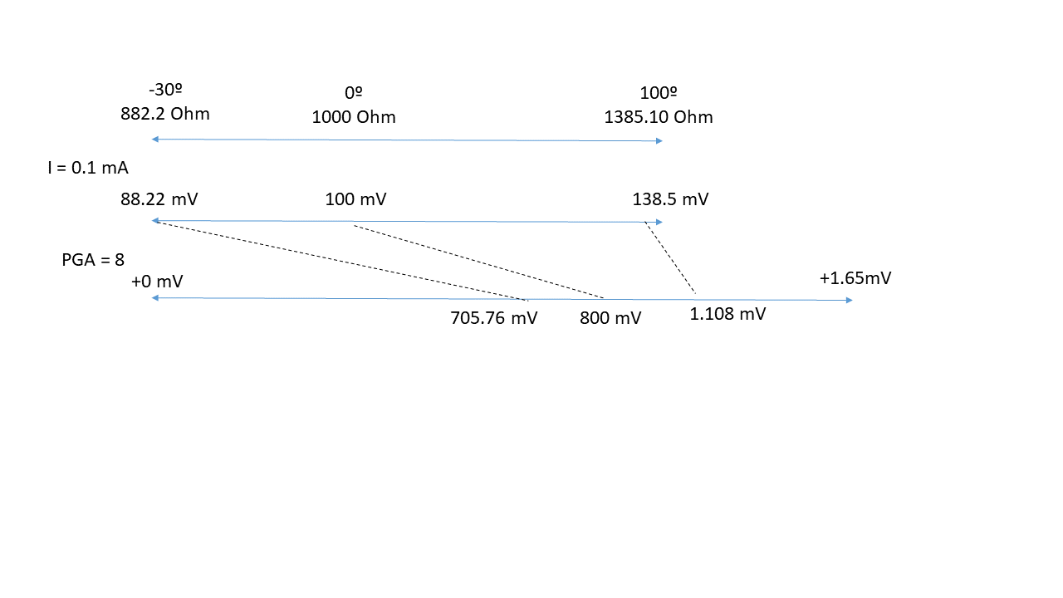

Equation 11 and 12:

VCMMIN=> VSS- 0.1 + 1/2 *G* VINMAX=0.1

## Digital Filter

